SOFTWARE ENGINEERING

AI-Powered Cross-Platform
Game Discovery System
Real-World Software System Analysis
NAME | Muhammad Hassan Tahir
REGISTRATION NO. | 2025-APC-105
PROGRAM | Applied Computing
SECTION | B
SESSION | 2025 Fall
Applied Computing • Section B • 2025 Fall

Selected System
Category: AI Recommendation System
System Chosen: An AI-powered, cross-platform Game Discovery and Recommendation System that suggests games to users based on a deep understanding of their taste — going beyond simple genre-tag matching used by platforms like Steam.

Problem Statement
Current game recommendation platforms, such as Steam, rely mainly on genre tags and purchase history, which leads to repetitive suggestions and limited discovery. Recommendations are also confined to a single storefront, so users never see relevant titles published on other platforms such as Epic Games, PlayStation, Xbox, or itch.io.
Users are rarely shown games outside their usual genre, even when they might enjoy them based on deeper traits such as mechanics, pacing, or mood — resulting in decision fatigue and reduced engagement over time.
This system aims to solve both problems: it aggregates games across all companies and platforms, and understands why a user likes a game — not just what it is tagged as — to recommend both familiar picks and genuine new discoveries.

A. Purpose
The purpose of this system is to help gamers discover titles that truly match their taste, regardless of which company published the game or which store sells it. Unlike existing platforms that recommend based on shallow signals (genre, tags, popularity), this system analyzes deeper traits — game mechanics, pacing, difficulty, art style, and mood — to build an accurate taste profile for each user.
It also intentionally introduces the user to new, unexpected games that match their underlying taste even if the genre is unfamiliar, helping them break out of repetitive recommendation loops while still respecting their preferences.

B. Users
■ Gamers / End Users — search, browse, and receive recommendations
■ Guest Users — browse limited recommendations without an account
■ System Administrators — manage platform integrations, monitor system health
■ Content Moderators — review flagged data, incorrect game metadata, or abuse reports

C. Stakeholders
■ Gamers — primary users of the platform
■ Game Publishers & Developers — e.g., Valve, Epic Games, Sony, Microsoft, indie studios — whose games are aggregated and promoted
■ Platform Owners / Investors — interested in growth, engagement, and revenue
■ Advertisers / Affiliate Partners — interested in exposure through recommended listings
■ Data Privacy Regulators — interested in compliance with data protection laws
■ Development & Support Team — responsible for building and maintaining the system

System Flow Diagram — Overall Architecture
The diagram below shows how user data flows through the system: from multi-platform aggregation, through the AI taste-understanding engine, to the final recommendation output, with a feedback loop that continuously refines the model.
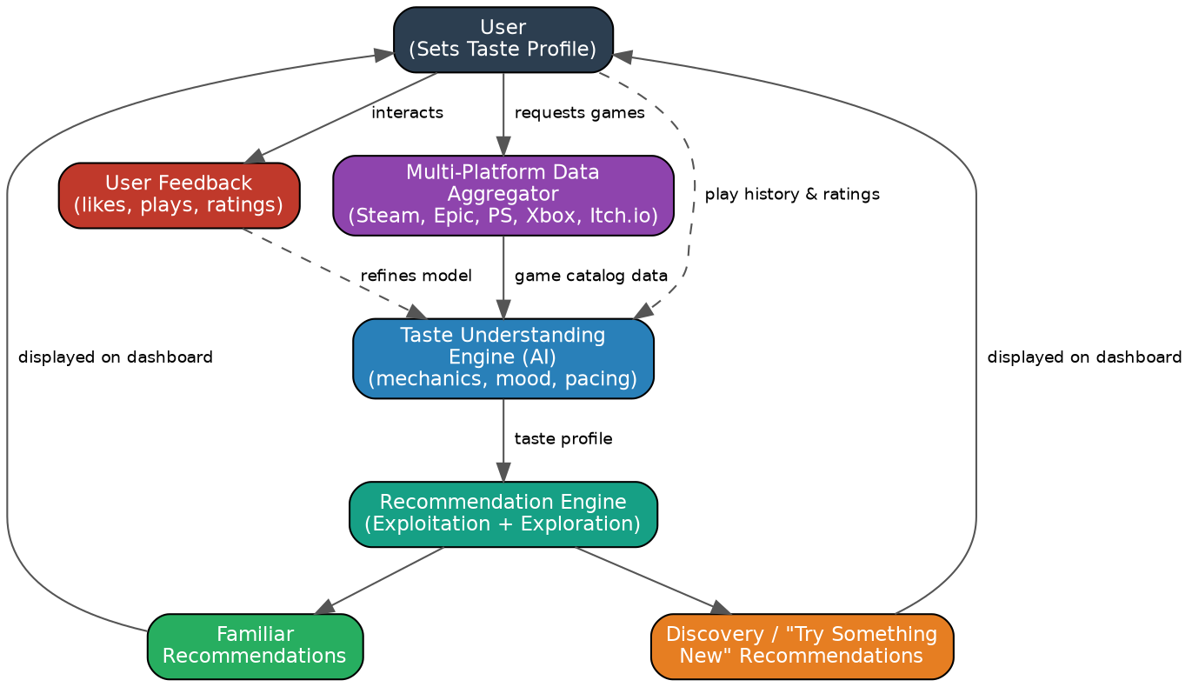
Figure 1: High-level system flow of the AI-Powered Game Discovery System

D. Functional Requirements (5)
# | Functional Requirement
1 | The system shall allow users to create an account and build a taste profile based on play history, ratings, and preferences.
2 | The system shall aggregate and display games from multiple publishers and platforms (e.g., Steam, Epic Games, PlayStation, Xbox, itch.io) in a unified catalog.
3 | The system shall generate personalized game recommendations using AI-based taste matching rather than genre-tag matching alone.
4 | The system shall provide a "Try Something New" / Discovery mode that recommends games outside the user's usual genre but aligned with their deeper taste traits.
5 | The system shall allow users to rate, like, or dismiss recommended games, and use this feedback to continuously refine future suggestions.

E. Non-Functional Requirements (5)
# | Non-Functional Requirement
1 | Performance: The system shall return recommendation results within 2 seconds under normal load.
2 | Scalability: The system shall support at least 1 million concurrent users without significant performance degradation.
3 | Security: All user data (play history, payment info, preferences) shall be encrypted in transit and at rest.
4 | Availability: The system shall maintain 99.9% uptime, excluding scheduled maintenance windows.
5 | Usability: The recommendation dashboard shall be understandable and navigable by a new user within their first 5 minutes of use, requiring no tutorial.

F. Risks (3)
# | Risk
1 | Data Integration Risk: APIs from different platforms (Steam, Epic, PlayStation, etc.) may change, restrict access, or provide inconsistent data, breaking the aggregation pipeline.
2 | Cold-Start Risk: New users with little to no play history are hard to recommend for accurately, potentially leading to poor first impressions.
3 | Bias / Overfitting Risk: The AI model may overfit to a user's short-term behavior (e.g., binge-playing one genre) and lose the balance between familiar and discovery recommendations.

G. Quality Attributes (3)
# | Quality Attribute
1 | Accuracy — recommendations should genuinely reflect the user's taste, not just surface-level tags.
2 | Reliability — the system should consistently return correct, up-to-date data from all integrated platforms.
3 | Maintainability — new platforms/publishers should be easy to integrate as the system grows.

H. Where AI Could Be Used
AI is used at the core of the recommendation engine to move beyond simple genre/tag matching. It analyzes deep gameplay traits — mechanics, pacing, difficulty curve, narrative style, and mood — extracted from a user's play history and ratings, and matches them against the full cross-platform game catalog.
The AI model deliberately balances two goals: exploitation (recommending closely matched, familiar-style games) and exploration (surfacing unexpected but relevant titles), similar to how streaming services balance familiar and new content — but tuned specifically for deeper gameplay traits rather than surface metadata.
Figure 2: AI recommendation pipeline showing the exploitation/exploration split

I. What Could Go Wrong If AI Is Used Incorrectly?
# | Risk of Incorrect AI Use
1 | Irrelevant "Discovery" Suggestions: If the exploration model is poorly tuned, "Try Something New" picks may feel random and unrelated, frustrating users and reducing trust in the platform.
2 | Filter Bubble Reinforcement: If exploitation is weighted too heavily, the AI may still trap users in narrow genre loops, defeating the system's core purpose.
3 | Bias and Unfair Promotion: The AI could unintentionally favor games from certain publishers (e.g., those with more available data or marketing partnerships) over smaller/indie developers, harming fairness and diversity in recommendations.
4 | Privacy Risk: Deep behavioral profiling (mood, play patterns) increases the risk of sensitive personal data being misused or exposed if the AI system or its training data is not properly secured.

Conclusion
The AI-Powered Cross-Platform Game Discovery System addresses a real gap in existing platforms like Steam by combining two things they lack: a unified catalog spanning every publisher and store, and a recommendation engine that understands the deeper reasons a player enjoys a game rather than just its genre tags.
By deliberately balancing familiar (exploitation) recommendations with intentional discovery (exploration), the system keeps suggestions relevant while still helping users break out of repetitive genre loops — directly solving the problem stated at the outset.
Careful attention to the identified risks — data integration, cold-start, bias, and privacy — along with the defined functional, non-functional, and quality requirements, ensures the system can be built not only to be innovative, but also reliable, fair, secure, and genuinely useful to its users.
— End of Assignment —

